SQL Developer
Task 5 - CASE Statements Documentation
Project Overview
This project focuses on using SQL CASE statements to transform and categorize student data based on specified conditions using the existing Students table.

Task Queries
Task 1: Assign Grades Based on Total Scores
sql
-- Task 1: Assign grades based on total scores
SELECT
studentid,
name,
mathscore,
sciencescore,
englishscore,
(mathscore + sciencescore + englishscore) as TotalScore,
CASE
WHEN (mathscore + sciencescore + englishscore) >= 270 THEN 'A+'
WHEN (mathscore + sciencescore + englishscore) >= 240 THEN 'A'
WHEN (mathscore + sciencescore + englishscore) >= 210 THEN 'B'
WHEN (mathscore + sciencescore + englishscore) >= 180 THEN 'C'
ELSE 'D (Fail)'
END AS Grade
FROM
students
ORDER BY
TotalScore DESC;

Output:
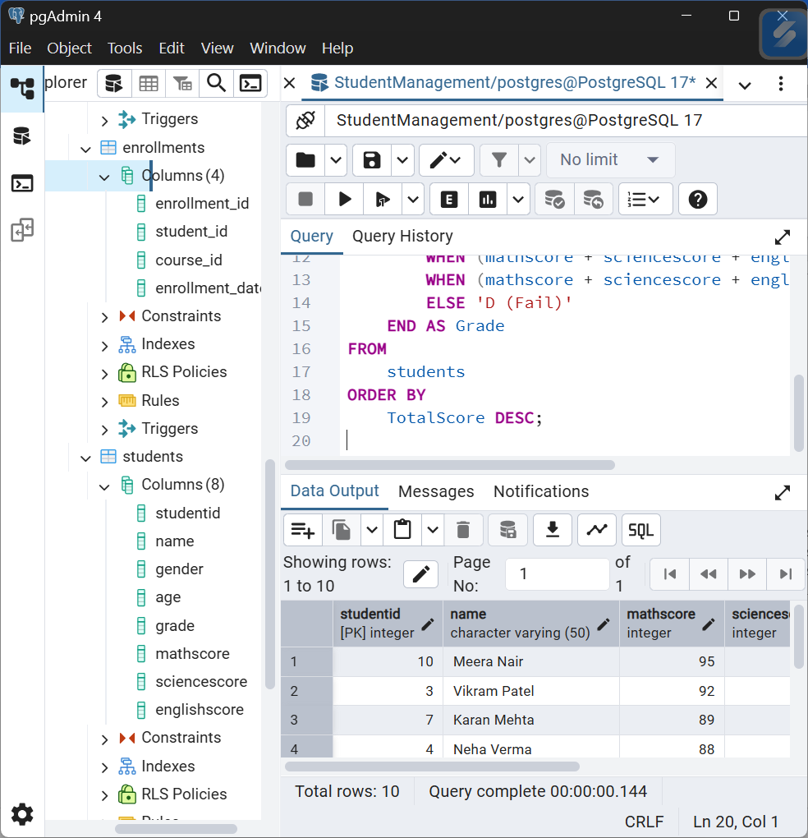

Task 2: Identify Pass/Fail Status in Specific Subjects
sql
-- Task 2: Pass/Fail status for each subject
SELECT
studentid,
name,
mathscore,
CASE
WHEN mathscore >= 40 THEN 'Pass'
ELSE 'Fail'
END AS Math_Status,
sciencescore,
CASE
WHEN sciencescore >= 40 THEN 'Pass'
ELSE 'Fail'
END AS Science_Status,
englishscore,
CASE
WHEN englishscore >= 40 THEN 'Pass'
ELSE 'Fail'
END AS English_Status,
-- Overall pass/fail status (must pass all subjects)
CASE
WHEN mathscore >= 40 AND sciencescore >= 40 AND englishscore >= 40 THEN 'Overall Pass'
ELSE 'Overall Fail'
END AS Overall_Result
FROM
students
ORDER BY
studentid;

Output:
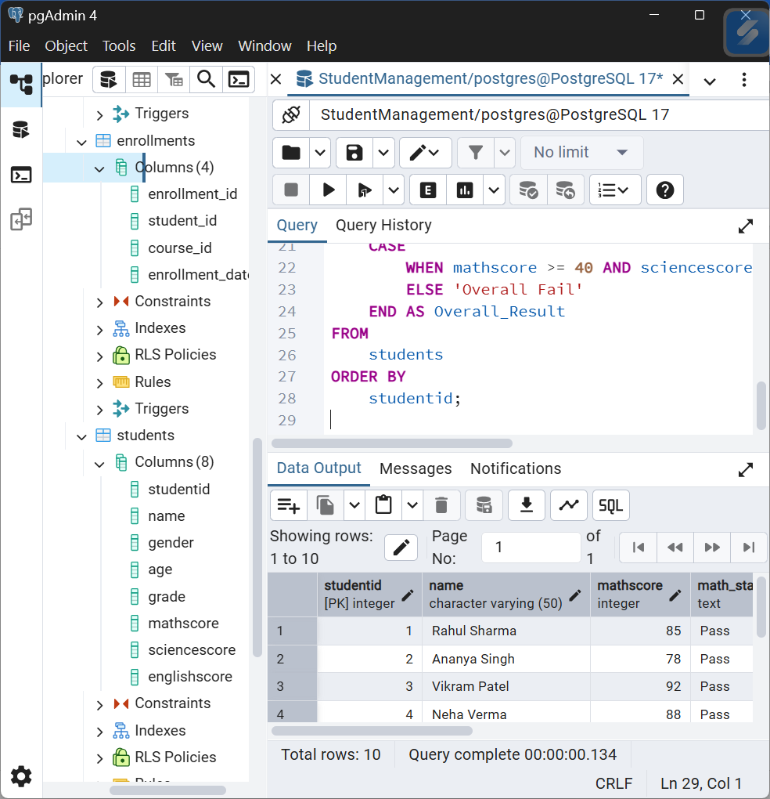

Expected Results Analysis
Task 1 Expected Grade Distribution:
Based on current data:
- A+ (≥270): Meera Nair (284)
- A (240-269): Vikram Patel (271), Karan Mehta (266), Neha Verma (264)
- B (210-239): Rahul Sharma (255), Pooja Iyer (234), Ananya Singh (233)
- C (180-209): Sneha Kapoor (226), Arjun Das (203)
- D/Fail (<180): Rohan Gupta (187)
Task 2 Expected Pass/Fail Status:
- All Subjects Pass: 9 students (all scores ≥40)
- Potential Failures: Based on 40 threshold, all students pass individual subjects
- Critical Cases: Rohan Gupta has lowest scores but still above 40 threshold

Key Insights from CASE Statement Analysis
Grade Distribution Insights:
- Top Performers: 1 student in A+ category, 3 students in A category
- Middle Cluster: 3 students in B category showing consistent performance
- Support Needed: 2 students in C category and 1 in D category need academic support
Pass/Fail Analysis:
- High Pass Rate: 100% of students pass individual subjects with 40 threshold
- Strong Performance: Most students significantly exceed passing threshold
- Quality Difference: While all pass, significant quality differences exist in performance levels
Performance Patterns:
- Grade A Students: Consistently achieve higher performance categories
- Balanced vs Specialized: Mix of students with balanced scores vs subject specialists
- Improvement Opportunities: Even passing students have room for significant improvement

